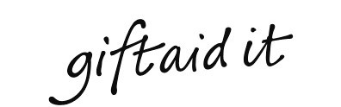
To:-
South Bucks RDA
Mill House Farm
Framewood Road
Fulmer
Bucks, SL2 4QR

If you are a UK tax payer and sign the declaration below, your donations will be increased by 25% where applicable.

Declaration
I would like to Gift Aid my donations (please tick all that apply):

Made today and in the past 4 years and in the future

I am a UK tax payer and understand that, if in any tax year my income tax and / or capital gains tax is less than the amount of Gift Aid claimed on all my donations, it is my responsibility to pay any difference.

Donor’s details

Title First name or initial(s)

Surname

Full home address

Post code Date ____________________________

Signed

Please return to the address at the top of this form

Please notify us if you:

- Want to cancel this declaration
- Change your name or home address
- No longer pay sufficient tax on your income and/or capital gains

If you pay Income Tax at the higher or additional rate and want to receive the additional tax relief due to you, you must include all your Gift Aid donations on your Self-Assessment tax return or ask HM Revenue and Customs to adjust your tax code. You can request an annual statement of your giving by emailing info@southbucksrda.org

South Bucks RDA enquiries@southbucksrda.org Registered Charity No 1136630
A Company Limited by Guarantee Registered in England No. 7282773

