MERRY CHRISTMAS

Well, hopefully Christmas will be better for everyone than last year. Things here are not
completely back to normal yet, as there are still several riders that haven’t returned as well as a
few schools with children who have special educational needs that don’t have the resources to
come back.

I would like to welcome all our new volunteers and to thank everyone else for their continued
support. The staff are very grateful for all your help in whatever capacity.
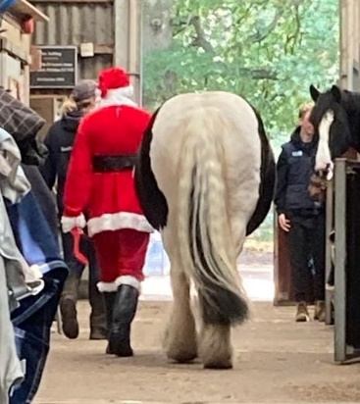
Let us hope that next year things continue to improve and that
there are no more enforced restrictions.

I would like to wish everyone a very Happy Christmas and
Healthy New Year and may you all stay free from COVID.

Di Redfern
Chair

Carol Service

Our Carol Service, led by Rev. Mike Bisset, with music provided by the Chiltern Music Academy
Senior Wind Band - was a truly wonderful event and got everyone into the Christmas spirit. We
were delighted that Joy Morrissey MP, and Mohammed Nazir Mayor of Slough could join us.

The backstage crew of volunteers, the fundraising committee, trustees and staff pulled out all
the stops to set up the indoor arena and make sure the event ran smoothly. And thank you to
the big man himself, Father Christmas, for stopping by to hand out chocolate from his grotto.

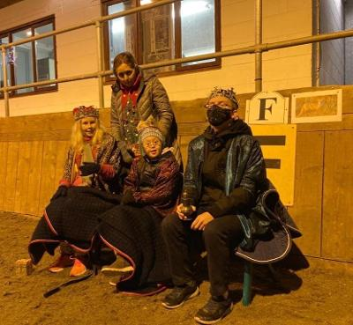
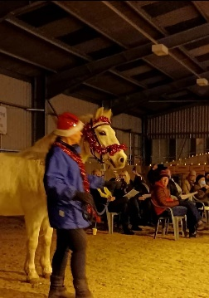
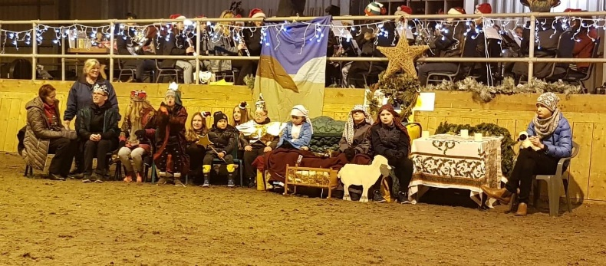

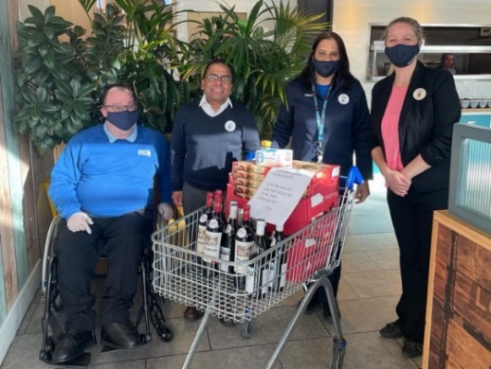
Thank you to Francis for organising and Ravi and Nadia at Tesco Slough for donating the mince pies and mulled wine ingredients for the Carol Concert. A big thank you for their amazing, continued support.

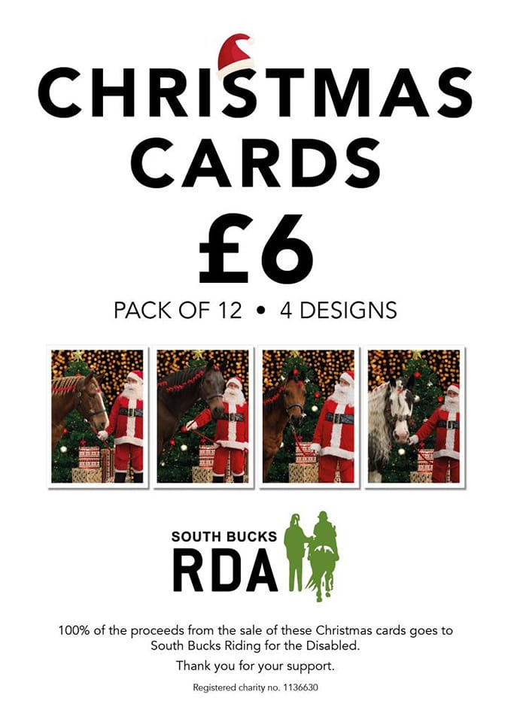

Yet again Emma, Hannah, Hayley, Harry and Nick (with a little help from Santa) produced, printed and donated our Christmas cards so that all proceeds from the sales come to South Bucks RDA. The cards can be found on the Gallery at the yard, or you can Contact Gina on 01753 662796 or Gina.Bailey@SouthBucksRDA.Org.

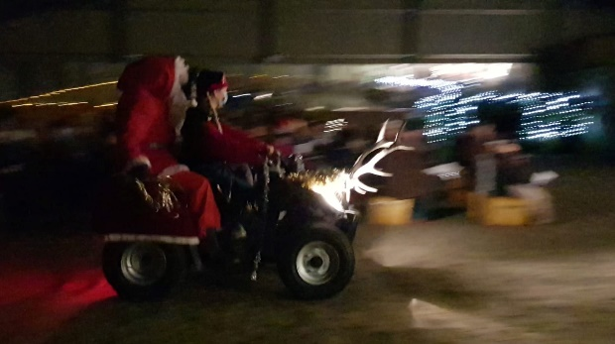
And please remember the following when doing your Christmas shopping
Amazon Smile – www.smile.amazon.co.uk
Easy Fundraising - www.Easyfundraising.org.uk

Our Horses (June - December 2021)

At long last, activities at South Bucks RDA are almost returning to a more normal way of life. Many of our riders have been able to return and the ponies too have enjoyed resuming contact with you all in the course of their job. Unfortunately, there are still a few riders who are not able to return as we do not have a suitable horse for their needs but please be assured that you have not been forgotten. We are still looking for that elusive 16hh horse, who has an “A” frame shape, who is safe and reliable and happy to work with disabled riders.

We have two new horses, both of whom have to learn what is required of an RDA horse before joining the team. They need to undergo lots of training in leading, coming into the mounting block and standing still, stopping and starting to the voice and many other specific requirements of an RDA horse.

In addition, the welfare of our horses and ponies is of paramount importance Do you know how many different services are required to keep all the horses comfortable and in tip top condition? You may be surprised, so we thought we would share this information with you :
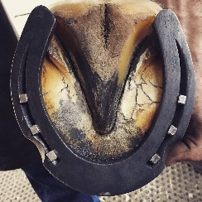
The Farrier: A BIG Thank You must go to Tom Anderson, our wonderful farrier, who comes each week to look after all the horses’ feet. Also, we are so lucky that he will always make time for us should one of the horses unexpectedly lose a shoe. Little wonder we keep him supplied with plenty of Tea and Cakes! Thank-you Tom - you are a Star!

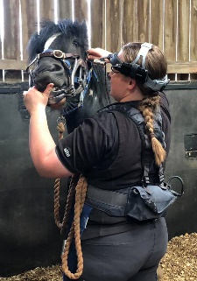
The Saddler: Sue Norton, visits twice a year to check the fit of saddles. This is essential because of the fluctuations in weight between Summer and Winter. Her last visit was in November, when all saddles were checked.

The Dentist: Most horses need a dental check-up once a year, but some require two visits. Regular visits from our Dentist, Grant Chanter, ensures that all the horses are kept comfortable in their mouths.

Flu/Tet Vaccinations. All RDA horses are supplied with this Vaccine free of charge by Pharmaceutical Companies like MSD Animal Health or Boehringer Ingelheim. It is injected by our Vet who also gives this service free of charge. We are extremely grateful for their generosity and service.

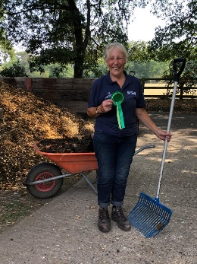
Worming: Before administering wormers we always have a “worm count” carried out on each horse. This was done recently, and all the results came back with a Zero worm count. So, a BIG Thank You to all of you who give up your time to come “poo picking”. Your efforts are very much appreciated.

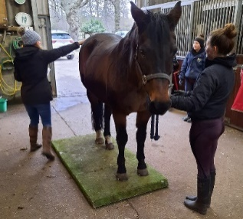
Weighbridge: Each week all the horses attend what we call weightwatchers. Using a Weigh Tape helps to keep a check on their condition and twice a year, Spillers-Feeds visit us with a portable weighbridge to accurately monitor the weight of each horse. We have just had a Winter visit and were pleased that all the horses recorded a sensible weight and condition score.

News of the horses in our Care

Billy Black: It has been a long road to recovery for Billy, but he is now hacking out daily with a member of staff. Despite his enforced box rest and a restricted grazing area over a long period of time, he has accepted this quite happily and taken everything in his stride. He has been such a good boy throughout, showing nothing but patience and kindness. A wonderful testimonial for a very special RDA horse. He is now on the “final straight” and we shall look forward to his return to classes in the not-too-distant future.

Freddie: Is making good progress and has been continuing his training in preparation for his debut into Classes in the New Year. He is a super pony who takes everything in his stride and is not fazed by any new experience. In addition to being led in Class without a rider he has now graduated to being led while being ridden by a member of staff. Freddie loves people and being involved with everything, so it was no surprise that he enjoyed entertaining the elderly visitors who came to “Tea with the Pony” which is a new activity for us. He also joined his friends Billy G, Pip and Forrester who all took part in our Christmas Carol Service. He was fascinated by the music of the 30-piece Brass Band, and you could imagine him humming along to the Carols.

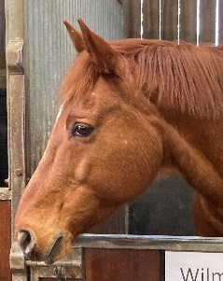
Wilma: Is a new horse who has just arrived and is settling in. He is a 16.1hh chestnut gelding who has the sweetest temperament. He shares a field with Forrester so they no doubt have lots to talk about. At the moment he is hacking out and learning how to be an RDA horse but will join in Classes as soon as he is considered ready.

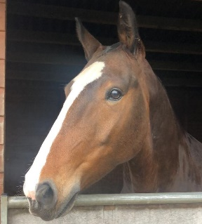
George: Is another new horse. He is a 15.1hh Maxi Cob who is 6yrs old. He is currently undergoing further Schooling and generally learning what is required of an RDA horse. He hacks out with Bruce to give him confidence and help him learn all about the different things he might meet in the Woods or on the Common such as deer, walkers and dogs, bicycles, children, prams etc and umbrellas which appear from behind bushes when it’s raining. He currently shares a field with Duke.

Mabel: Is everyone’s favourite and works hard helping many different riders each week. She is really looking forward to a break from lessons and a different routine over the Christmas periods. In the meantime, she is enjoying Massage treatment with a magnetic rug which helps to ease her muscles.

Lambrusco

In November we announced the passing of Lambrusco III, aka ‘Brusco’ or ‘Lambo’ – our unicorn. Lambrusco touched the hearts of many riders, all the volunteers, and the members of staff who have had the pleasure to work alongside him over the years.
Lambrusco carried many riders to international, national and regional success, predominantly in Para and RDA Dressage, and in his later years in RDA Countryside Challenge. At home he was well regarded as a true gentleman, looking after all his riders and happy to turn his hoof to anything that was asked of him. Lambrusco loved the adoration of a crowd and would grow in stature with a spring in his step if he thought the spotlight was on him.

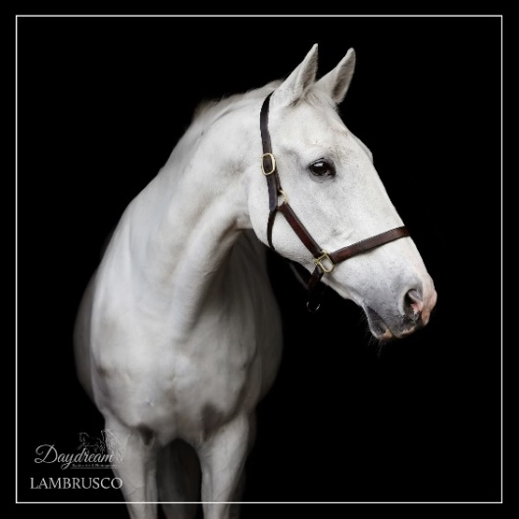

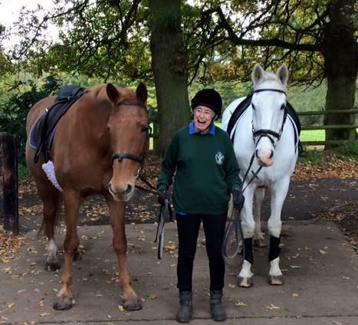
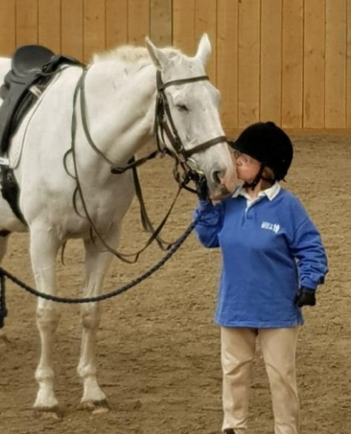

Our volunteers

A HUGE thank you to all our volunteers, getting started again after the various lockdowns has been challenging for everyone, your smiles, hard work and fun are really appreciated.
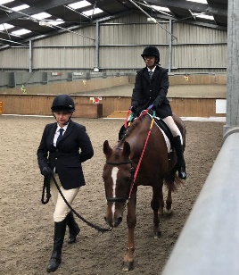
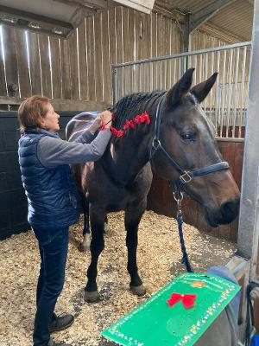
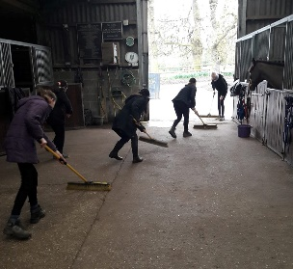
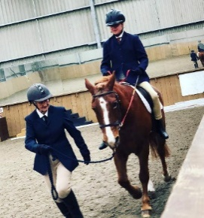

A special thank you to two amazing women – Romilly Hart and Emma Moore, without whom I am not sure we would function quite as well as we do!

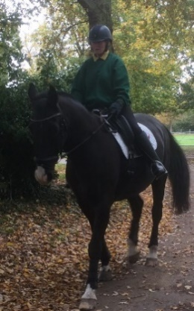
Romilly for supporting the yard over
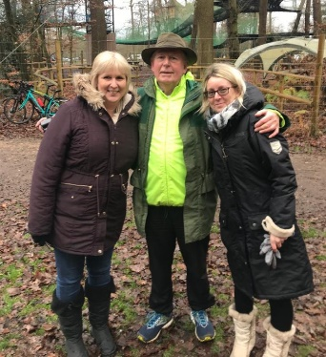
the past year, sorting tack for sale & fundraising

Emma for fundraising,
Christmas cards, cleaning and keeping all fed with
amazing cakes

Tea with a Pony

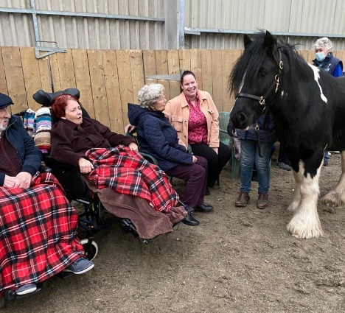
Visitors from Woodland Manor Care Home enjoying meeting
Freddie. This new venture has been very successful and
will be increased once the warmer weather
returns. Residents from care homes enjoy tea and cake and
visit the stables and meet one or two of the ponies This has
attracted volunteers who enjoy a different challenge, so
please let Gina know if you would be interested in joining this
group.

Training

If you are interested in different areas that are connected to RDA, National Office have some
great e-learning modules that you might find useful and interesting about:
- Disability Awareness
- Autism Awareness
- Equine knowledge
You can register at https://www.rda-learning.org.uk/

Robert Pickles (BHS Fellow) ran a training day for staff and coaches October, great fun looking
at rider position on ‘Mike’ the mechanical horse and practice teaching with real ponies. We’re
hoping to have Robert with us on a quarterly basis, if any volunteers would like to come along or
have ideas for training, please let Gem know.
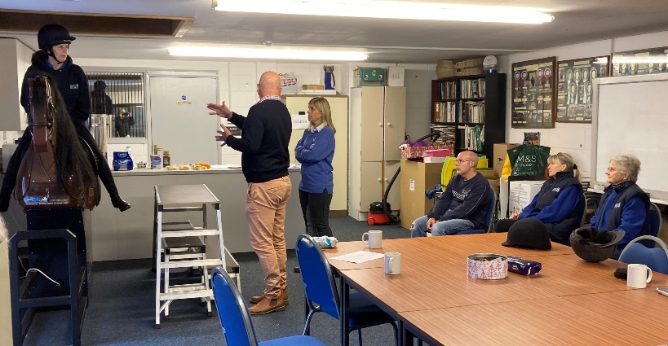

First aid training was carried out in the Summer for staff and volunteers. Chloe practiced on
Gem (who is awake, really!)
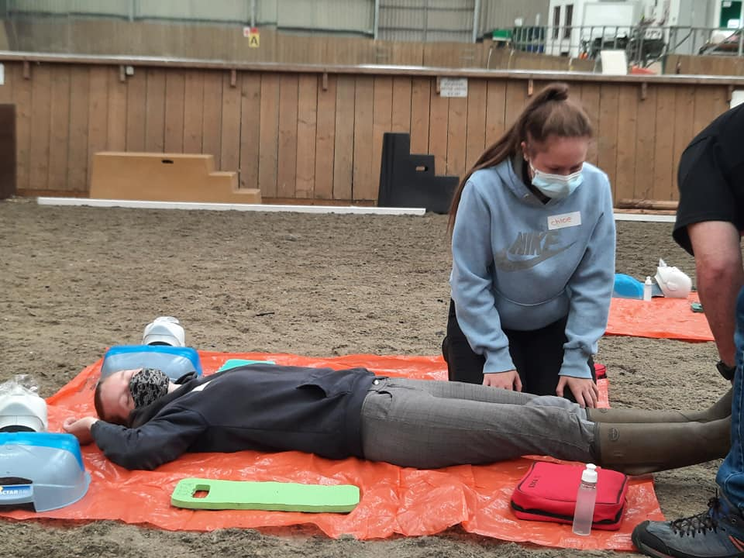

Our Riders

Due to Covid this year the National Championships also became virtual with countryside
challenge and dressage tests being videoed and sent in to be judged. As always, our riders
were brilliant. Well done everyone.
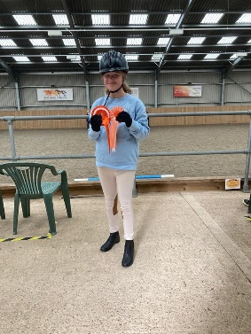
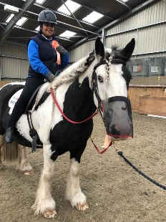
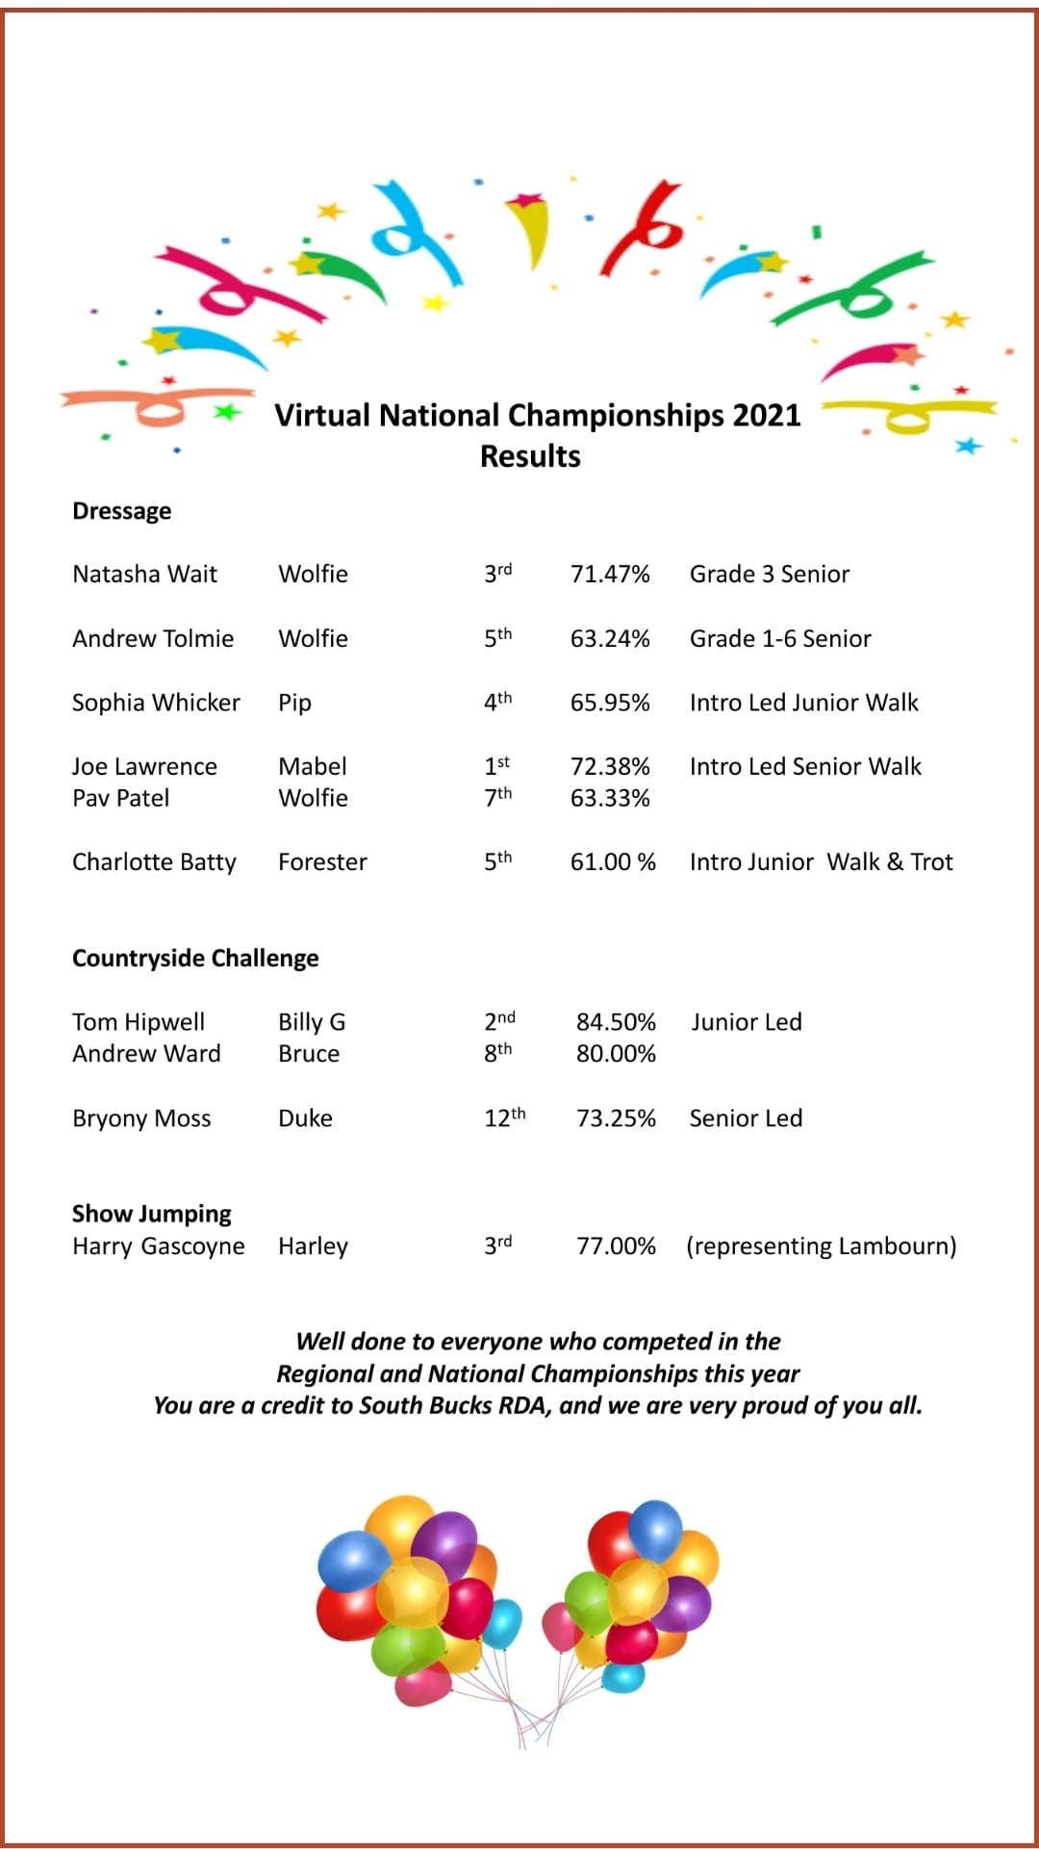

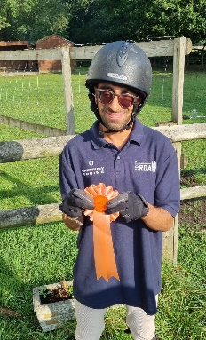
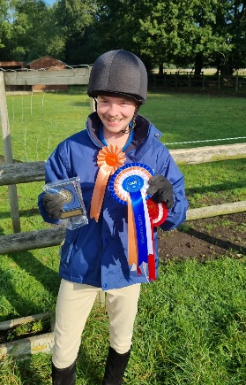

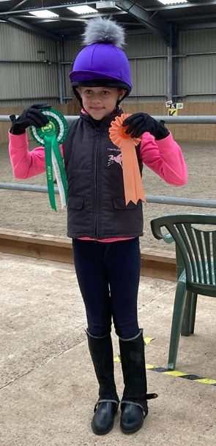

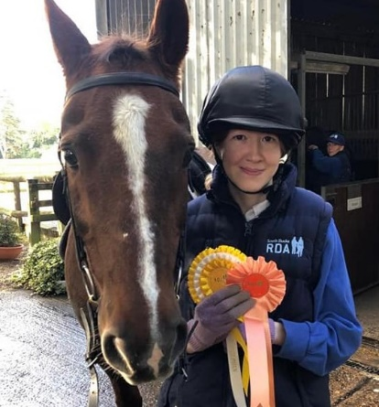

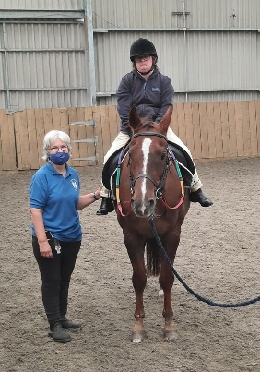
In August we had a visit from Fiona Caley, she came for a birthday ride.
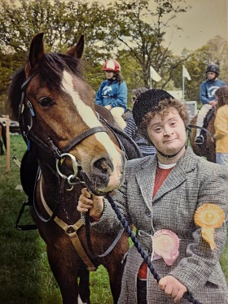
Fiona was a regular rider at South Bucks RDA from 1973 until 2007. Lots of happy memories have come flooding back looking at the old photos of Fiona - it was lovely to see you again.

Coteford Junior School
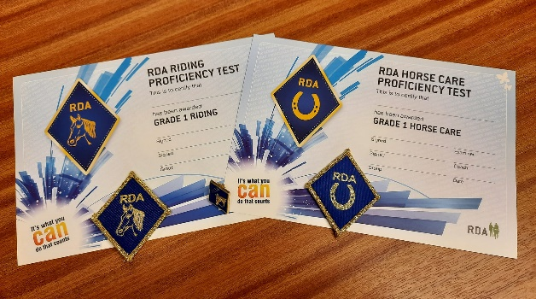
This Term we were thrilled to finally be able to welcome eight new riders from Coteford Junior School who were all very excited to be starting their Riding Journey with South Bucks. To help them remember what they have done, each week they complete a section in “My Riding Journey” which is a personal diary, created by Emma Ford, to help the children log details of their activities and progress made during their time with us.

They are all very keen to learn and have been making such good progress that, Bradley, Daniel, Flynn, Isa, Jack, Lauren, Miles and Rio have passed their Grade 1 Proficiency Test in Riding and Horse Care Syllabus A & B with full marks. Their Examiner, Anne Coney, was pleased with their riding ability and the depth of their Horse Care knowledge.
The last day of the Coteford riding term was a “fun” day of games designed to develop their hand/eye co-ordination and other skills and the Wednesday Volunteers dressed in festive hats and jumpers to encourage the children into the festive spirit and to look forward to the start of the School Christmas activities.

Staff

A little update on our amazing staff. We continue our search for a new Centre Manager, in the
meantime Gem as Yard Manager is doing a fabulous job, working with our horses, riders,
volunteers and managing Chloe and Fern – Thank you Gem.
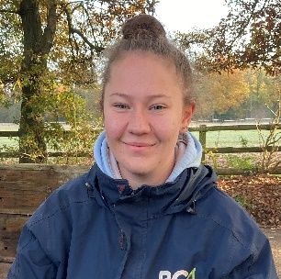
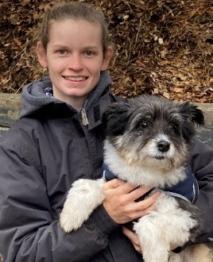

Gem (and Billy) works Tuesday – Saturday Chloe is now working full time Sunday - Thursday
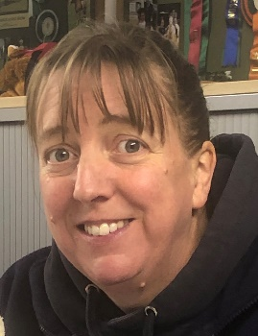
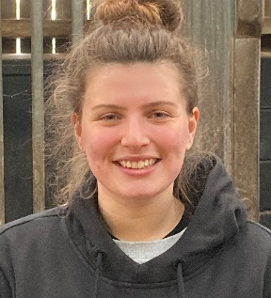

Fern has joined us from Heathrow Special Gina – Administration- keeping us all organised
Needs Centre, works Wednesday - Friday. Works Monday, Tuesday, Thursday, Friday

Kat works Sunday afternoons and Monday.

Gem and Gina are managed by the Operations Management Team of Di, Theresa, Hilary, Julie

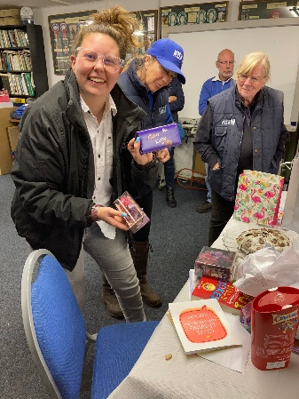
And sadly, Katie has decided to leave SBRDA to move on to
pastures new. Good Luck Katie.

Thank You

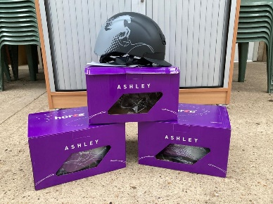
To the Roland Callingham Foundation for funding the purchase of much needed new equipment, including hats, poles, cones and beanbags.

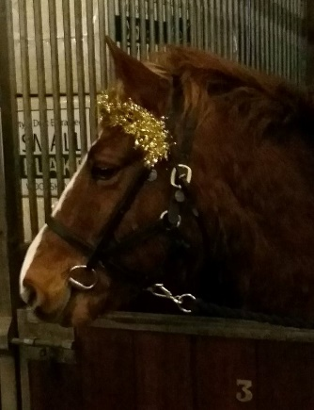
For the continued support of Gerrards Cross and Chalfont Rotary Club which is very much appreciated. They recently hosted a dinner at Beaconsfield Golf Club in aid of South Bucks RDA where the local MP Joy Morrisey was the guest speaker. As she had visited the Group earlier in the year, she was able to give a first-hand account of the work carried out here. She gave a glowing report on the riders, parents, volunteers and extended her praise to the horses and ponies as well.

Gerrards Cross and Chalfont Rotary Club have sponsored Rotarian (Forester) for several years now for which the Group is very grateful.

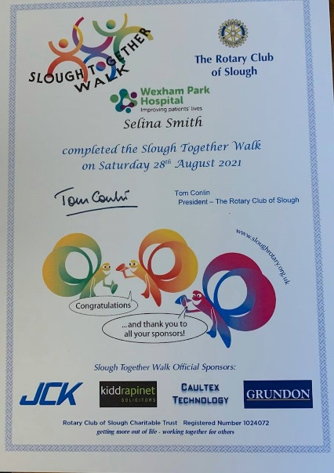
To the Rotary Club of Slough for a lovely dinner and their continued support through The Slough Together Walk. The walk is an annual event supporting local charities including South Bucks. Keep the date for your diary next year, 2022 details on the next page.

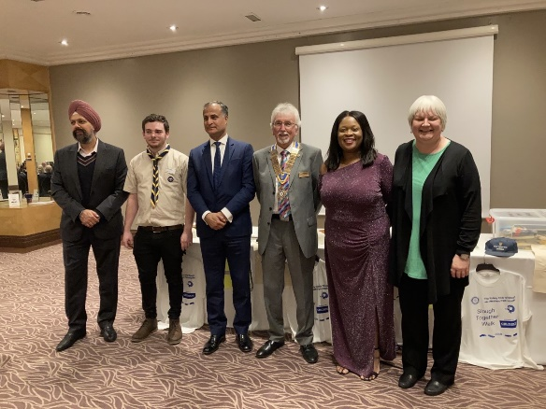
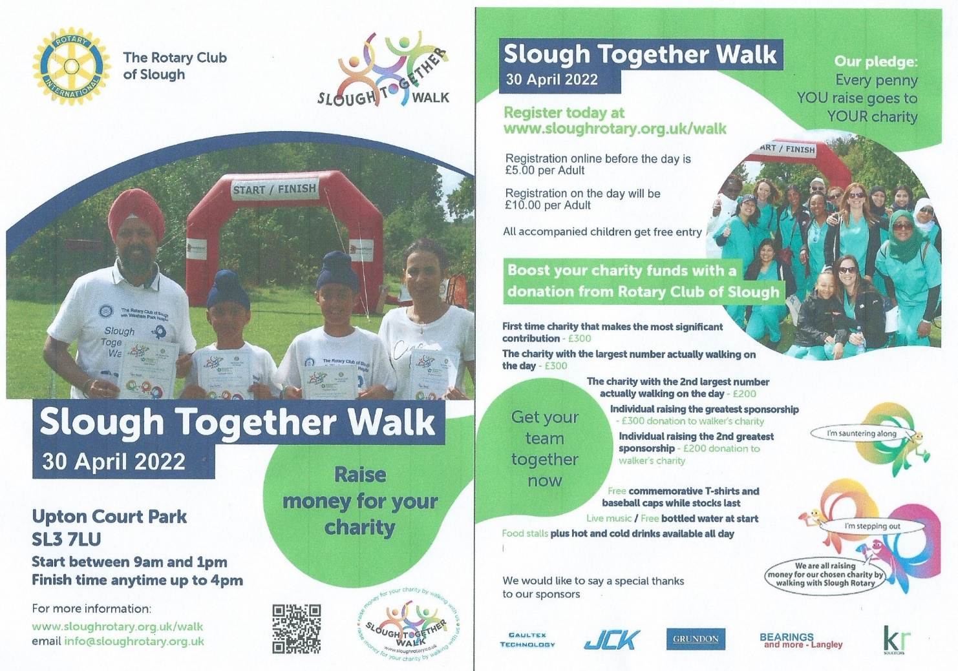

On a more serious note - Covid

Thank you for your continued support during these challenging times and for being safe whilst
enjoying our facilities and services. We still need to ensure we follow Government and RDA
National Office guidelines to reduce the risk of transmission.

- If you are at all unwell, please do not come up.
- Please sign in with a phone number and use the NHS track & trace QR code.
- If you are side helping and not in the rider’s bubble, it is advised you wear face covering.
- Hands, tack and hats need to be sanitised between rides and when using equipment.
- The classroom door should be kept open with 3 or more people to ensure maximum ventilation.

WE WISH YOU ALL A HAPPY CHRISTMAS
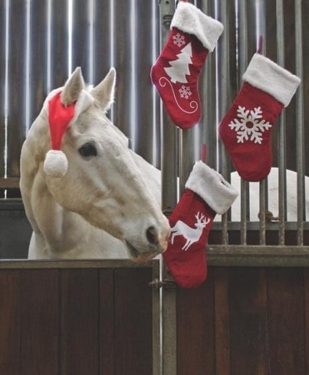
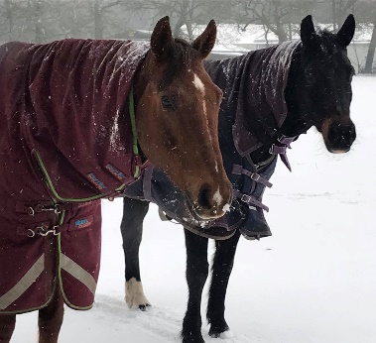
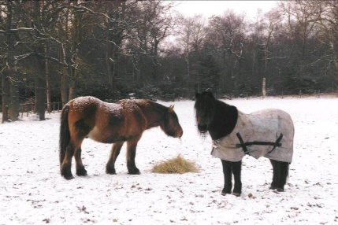

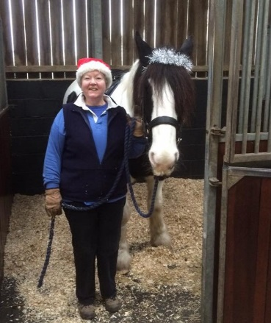
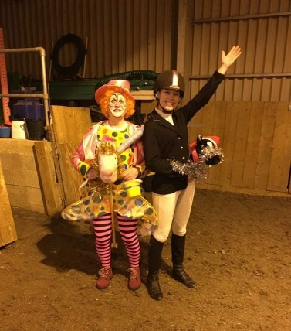

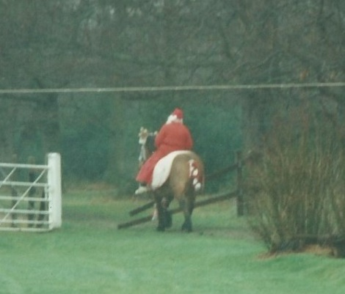
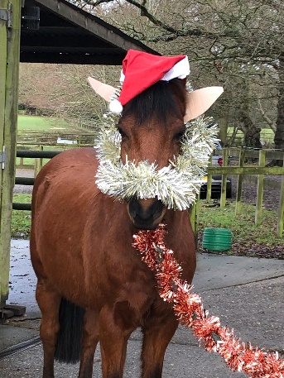
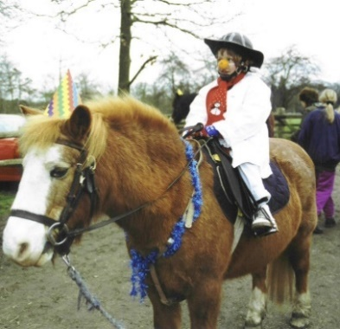
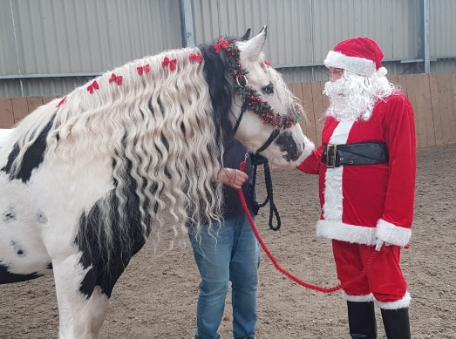

AND A WONDERFUL 2022

